Document Control
Version | Date | Details
V1.0 | 2/29/16 | Metric specifications not arranged by Project  Metric specifications in native format without editing
V2.0 | 3/7/16 | Metrics arranged by Project  Metric specifications edited for PRIME

Metric Questions or Feedback:
A link to a form is provided. Please complete one form for each request for clarification per metric. You may submit additional requests as needed.

Project 1.3 Ambulatory Care Redesign: Specialty Care Eligible Population

The PRIME Eligible Population includes the combination of both Population #1 and Population #2. An individual does not have to meet criteria of both Population #1 and Population #2.
Population #1:
Individuals of all ages with at least 2 encounters with the PRIME Entity Primary Care team during the measurement period.
- A Primary Care team encounter is counted if occurred with a member of the Primary Care Team from Family Medicine, Internal Medicine, or Pediatrics. The PRIME Entity may choose to include populations who are seen for primary care in a specialty clinic (e.g. HIV)
- Encounters include either a face-to-face visit with a primary care provider OR any encounter included in the list of eligible non-traditional service types described in the Global Payment Program (for PRIME, encounters not limited to uninsured individuals.)
Population #2
Individuals of all ages who are in Medi-Cal Managed Care with 12 months of continuous assignment to the PRIME Entity for all 12 months of the Measurement Period.
- No more than one gap in enrollment or assignment with the PRIME Entity of up to 45 days during the Measurement Period.
Individual must be enrolled in the primary plan and assigned to the PRIME Entity on the final day of the Measurement Period.

……………………………..

For these 3 metrics - DHCS All-Cause Readmission, NQF 0041 Influenza Immunization, and NQF 0028 Tobacco Assessment/Counseling - the Project 1.3 Target Population are those in the
- PRIME Eligible Population AND
- for whom DPH/DMPH Specialty Care Expertise has been requested at least once during the Demonstration Year

For these 4 metrics – Closing the Referral Loop, Post Procedure ED visits, Referral Reply Turnaround, and Specialty Care Touches – the Project 1.3 Target Population does not necessarily apply. The denominator is only defined by the metric denominator.

Note: Specifications for PRIME measures that are CMS Core measures refer to CMS value sets

Measurement Period
Demonstration Year | Mid-Year Report Measurement Period | Final Year-End Report Measurement Period
DY 11 | Not applicable | Jul 1, 2015 – Jun 30, 2016
DY12 | Jan 1, 2016 – Dec 31, 2016 | Jul 1, 2016 – Jun 30, 2017
DY13 | Jan 1, 2017 – Dec 31, 2017 | Jul 1, 2017 – Jun 30, 2018
DY14 | Jan 1, 2018 – Dec 31, 2018 | Jul 1, 2018 – Jun 30, 2019
DY15 | Jan 1, 2019 – Dec 31, 2019 | Jul 1, 2019 – Jun 30, 2020

Summary Table
NQF # 0041 Influenza Immunization
Specification Source: 2016 PQRS Individual Claims Registry Measure Specification Supporting Documents v. 11/17/15
Numerator: Patients who received an influenza immunization OR who reported previous receipt of an influenza immunization.
Denominator: All patients aged 6 months and older seen for a visit between October 1 and March 31.
NQF 0028: Tobacco Assessment and Counseling
Specification Source: 2016 PQRS Individual Claims Registry Measure Specification Supporting Documents v. 11/17/15
Numerator: Patients who were screened for tobacco use* at least once during the two-year measurement period AND who received tobacco cessation counseling intervention** if identified as a tobacco user. *Includes use of any type of tobacco. ** Cessation counseling intervention includes brief counseling (3 minutes or less), and/or pharmacotherapy
Denominator: All patients aged 18 years and older seen for at least two visits or at least one preventive visit during the measurement period
Post procedure ED visits/admissions
Specification Source: PRIME Innovative Measure Steward
Numerator: Number of PRIME entity emergency department visits resulting from an outpatient specialty procedure/operation completed in the prior 7 days
Denominator: Total number of individuals in the eligible population with an outpatient specialty procedure/operation at the PRIME entity facility during the measurement period
Referral Reply Turnaround Rate
Specification Source: PRIME Innovative Measure Steward
Numerator: Number of requests in denominator for whom the request for specialty expertise received a response within 4 calendar days.
Denominator: Total number of requests, during the measurement period, for individuals in the Eligible Population who were referred for specialty expertise from the PRIME entity
Specialty Care Touches: Specialty expertise requests managed via non-face to face specialty encounters
Specification Source: PRIME Innovative Measure Steward
Numerator: Number of requests for specialty expertise from the denominator that are managed via non-face to face specialty encounters.
Denominator: Total number of requests, within the measurement period, for DPH/DMPH specialty expertise
Closing the referral loop: receipt of specialist report (CMS50v4)
Specification Source: CMS50v4
Numerator: Number of patients with a referral, for which the referring provider received a report from the provider to whom the patient was referred.
Denominator: Project 1.3 Target Population
DHCS All-Cause Readmissions – Statewide Collaborative QIP measure
Specification Source: DHCS QIP All-Cause Readmission Baseline Report Appendix B June 2013-May2014
Numerator: At least one acute readmission for any diagnosis within 30 days of the Index Discharge Date on or between the first and last day of the measurement year.
Denominator: Patients 21 years of age and older in the Project 1.3 Target Population

NQF 0041: Preventative Care and Screening: Influenza Immunization

DESCRIPTION:
Percentage of patients aged 6 months and older seen for a visit between October 1 and March 31 who received an influenza immunization OR who reported previous receipt of an influenza immunization

INSTRUCTIONS:
This measure is to be reported a minimum of once for visits for patients seen between January and March for the 2015-2016 influenza season AND a minimum of once for visits for patients seen between October and December for the 2016-2017 influenza season. This measure is intended to determine whether or not all patients aged 6 months and older received (either from the reporting physician or from an alternate care provider) the influenza immunization during the flu season. There is no diagnosis associated with this measure. This measure may be reported by
clinicians who perform the quality actions described in the measure based on the services provided and the measure-specific denominator coding.

If reporting this measure between January 1, 2016 and March 31, 2016, quality-data code G8482 should be reported when the influenza immunization is administered to the patient during the months of August, September, October, November, and December of 2015 or January, February, and March of 2016 for the flu season ending March 31,
2016.

• If reporting this measure between October 1, 2016 and December 31, 2016, quality-data code G8482 should be reported when the influenza immunization is administered to the patient during the months of August, September, October, November, and December of 2016 for the flu season ending March 31, 2017.
• Influenza immunizations administered during the month of August or September of a given flu season(either 2015-2016 flu season OR 2016-2017 flu season) can be reported when a visit occurs during the flu season (October 1 - March 31). In these cases, G8482 should be reported.

Measure Reporting via Claims:
CPT or HCPCS codes and patient demographics are used to identify patients who are included in the measure’s denominator. Quality-data codes are used to report the numerator of the measure.

When reporting the measure via claims, submit the listed CPT or HCPCS codes, and the appropriate numerator quality-data code. All measure-specific coding should be reported on the claim(s) representing the eligible encounter.

Measure Reporting via Registry:
CPT or HCPCS codes and patient demographics are used to identify patients who are included in the measure’s denominator. The listed numerator options are used to report the numerator of the measure.

The quality-data codes listed do not need to be submitted for registry-based submissions; however, these codes may be submitted for those registries that utilize claims data.

DENOMINATOR:
All patients aged 6 months and older, in the Project 1.3 Target Population, seen for a visit between October 1 and March 31

Denominator Criteria (Eligible Cases):
Patients in the Project 1.3 Target Population
AND
aged ≥ 6 months seen for a visit between October 1 and March 31
AND
Patient encounter during the reporting period (CPT or HCPCS): 90945, 90947, 90951, 90952, 90953,
90954, 90955, 90956, 90957, 90958, 90959, 90960, 90961, 90962, 90963, 90964, 90965, 90966, 90967,
90968, 90969, 90970, 99201, 99202, 99203, 99204, 99205, 99212, 99213, 99214, 99215, 99304, 99305,
99306, 99307, 99308, 99309, 99310, 99315, 99316, 99324, 99325, 99326, 99327, 99328, 99334, 99335,
99336, 99337, 99341, 99342, 99343, 99344, 99345, 99347, 99348, 99349, 99350, G0438, G0439

NUMERATOR:
Patients who received an influenza immunization OR who reported previous receipt of an influenza immunization

Numerator Instructions:
The numerator for this measure can be met by reporting either administration of an influenza vaccination or that the patient reported previous receipt of the current season’s influenza immunization. If the performance of the numerator is not met, a clinician can report a valid performance exclusion for having not administered an influenza vaccination. For clinicians reporting a performance exclusion for this measure, there should be a clear rationale and documented reason for not administering an influenza immunization if the patient did not indicate previous receipt, which could include a medical reason (e.g., patient allergy), patient reason (e.g., patient declined), or system reason (e.g., vaccination not available). The system reason should be indicated only for cases of disruption or shortage of influenza vaccination supply.

Definition:
Previous Receipt – Receipt of the current season’s influenza immunization from another provider OR from same provider prior to the visit to which the measure is applied (typically, prior vaccination would include influenza vaccine given since August 1st).

Numerator Quality-Data Coding Options for Reporting Satisfactorily: Influenza Immunization Administered
Performance Met: G8482: Influenza immunization administered or previously received
OR
Influenza Immunization not Administered for Documented Reasons
Other Performance Exclusion: G8483: Influenza immunization was not administered for
reasons documented by clinician (e.g., patient allergy or other medical reasons, patient declined or other patient reasons, vaccine not available or other system reasons)
OR
Influenza Immunization not Administered, Reason not Given
Performance Not Met: G8484: Influenza immunization was not administered, reason not given

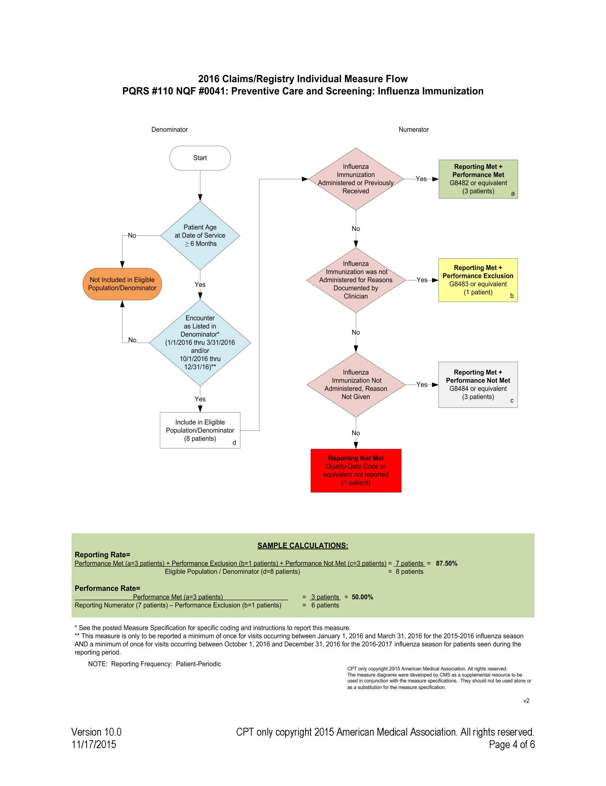
2016 Claims/Registry Individual Measure Flow
PQRS #110 NQF #0041: Preventive Care and Screening: Influenza Immunization

Please refer to the specific section of the Measure Specification to identify the denominator and numerator information for use in reporting this Individual Measure.

1. Start with Denominator

2. Check Patient Age:

a. If the Age is greater than or equal to 6 months of age on Date of Service and equals No during the measurement period, do not include in Eligible Patient Population. Stop Processing.

b. If the Age is greater than or equal to 6 months of age on Date of Service and equals Yes during the measurement period, proceed to check Patient Encounter.

3. Check Encounter Performed:

a. If Encounter as Listed in the Denominator equals No, do not include in Eligible Patient Population. Stop Processing.

b. If Encounter as Listed in the Denominator equals Yes, include in the Eligible population.

4. Denominator Population:

a. Denominator population is all Eligible Patients in the denominator. Denominator is represented as Denominator in the Sample Calculation listed at the end of this document. Letter d equals 8 patients in the sample calculation.

5. Start Numerator

6. Check Influenza Immunization Administered or Previously Received:

a. If Influenza Immunization Administered or Previously Received equals Yes, include in Reporting Met and Performance Met.

b. Reporting Met and Performance Met letter is represented in the Reporting Rate and Performance Rate in the Sample Calculation listed at the end of this document. Letter a equals 3 patients in Sample Calculation.

c. If Influenza Immunization Administered or Previously Received equals No, proceed to Influenza
Immunization Not Administered for Documented Reasons.

7. Check Influenza Immunization was not administered for Reasons Documented by Clinician:

a. If Influenza Immunization was not administered for Reasons Documented by Clinician equals Yes, include in Reporting Met and Performance Exclusion.

b. Reporting Met and Performance Exclusion letter is represented in the Reporting Rate and Performance Rate in the Sample Calculation listed at the end of this document. Letter b equals 1 patient in the Sample Calculation.

c. If Influenza Immunization was not Administered for Reasons Documented by Clinician equals No, proceed to Influenza Immunization was Not Administered, Reason Not Given

8. Check Influenza Immunization Not Administered, Reason Not Given:

a. If Influenza Immunization Not Administered, Reason Not Given equals Yes, include in the Reporting Met and Performance Not Met.

b. Reporting Met and Performance Not Met letter is represented in the Reporting Rate in the Sample Calculation listed at the end of this document. Letter c equals 3 patients in the Sample Calculation.

c. If Influenza Immunization Not Administered, Reason Not Given equals No, proceed to Reporting Not Met.

9. Check Reporting Not Met:

a. If Reporting Not Met equals No, Quality Data Code or equivalent not reported. 1 patient has been subtracted from the reporting numerator in the sample calculation.

NQF 0028: Tobacco Use – Screening and Cessation Intervention

DESCRIPTION:
Percentage of patients aged 18 years and older who were screened for tobacco use one or more times within 24 months AND who received cessation counseling intervention if identified as a tobacco user

INSTRUCTIONS:
This measure is to be reported once per reporting period for patients seen during the reporting period. This measure is intended to reflect the quality of services provided for preventive screening for tobacco use.

Measure Reporting via Claims:
CPT or HCPCS codes and patient demographics are used to identify patients who are included in the measure’s denominator. CPT Category II codes are used to report the numerator of the measure.

When reporting the measure via claims, submit the appropriate CPT or HCPCS codes, and the appropriate CPT Category II code OR the CPT Category II code with the modifier. The modifiers allowed for this measure are: 1P- medical reasons, 8P- reason not otherwise specified. All measure-specific coding should be reported on the claim(s) representing the eligible encounter.

Measure Reporting via Registry:
CPT or HCPCS codes and patient demographics are used to identify patients who are included in the measure’s denominator. The listed numerator options are used to report the numerator of the measure.

The quality-data codes listed do not need to be submitted for registry-based submissions; however, these codes may be submitted for those registries that utilize claims data.

DENOMINATOR:
All patients aged 18 years and older in the Project 1.3 Target Population

Denominator Criteria (Eligible Cases):
PRIME Eligible Population
AND
Patients aged ≥ 18 years on date of encounter
AND
Patient encounter during the reporting period (CPT or HCPCS): 90791, 90792, 90832, 90834, 90837, 90845, 92002, 92004, 92012, 92014, 92521, 92522, 92523, 92524, 92540, 92557, 92625, 96150, 96151, 96152, 97003, 97004, 99201, 99202, 99203, 99204, 99205, 99212, 99213, 99214, 99215, 99406, 99407, G0438, G0439

Denominator Exclusions:
*Severe Mental Illness

Denominator Exclusions Criteria:
*Severe Mental Illness

NUMERATOR:
Patients who were screened for tobacco use at least once within 24 months AND who received tobacco cessation intervention if identified as a tobacco user

Definitions:
Tobacco Use – Includes use of any type of tobacco.
Tobacco Cessation Intervention – Includes brief counseling (3 minutes or less), and/or pharmacotherapy.

NUMERATOR NOTE: In the event that a patient is screened for tobacco use and identified as a user but did not receive tobacco cessation intervention report 4004F with 8P.

Numerator Quality-Data Coding Options for Reporting Satisfactorily:

Patient Screened for Tobacco Use, Identified as a User and Received Intervention
Patient screened for tobacco use AND received tobacco cessation intervention (counseling, pharmacotherapy, or both), identified as a tobacco user
Performance Met: CPT II 4004F: Patient screened for tobacco use AND received tobacco cessation intervention (counseling, pharmacotherapy, or both), if identified as a tobacco user

OR
Patient Screened for Tobacco Use and Identified as a Non-User of Tobacco
Performance Met: CPT II 1036F: Current tobacco non-user

OR
Tobacco Screening not Performed for Medical Reasons
Append a modifier (1P) to CPT Category II code 4004F to report documented circumstances that appropriately exclude patients from the denominator
Medical Performance Exclusion: 4004F with 1P: Documentation of medical reason(s) for not screening for tobacco use (eg, limited life expectancy, other medical reasons)

OR
Tobacco Screening OR Tobacco Cessation Intervention not Performed, Reason Not Otherwise
Specified
Append a reporting modifier (8P) to CPT Category II code 4004F to report circumstances when the action described in the numerator is not performed and the reason is not otherwise specified.
Performance Not Met: 4004F with 8P: Tobacco screening OR tobacco cessation intervention not performed, reason not otherwise specified.

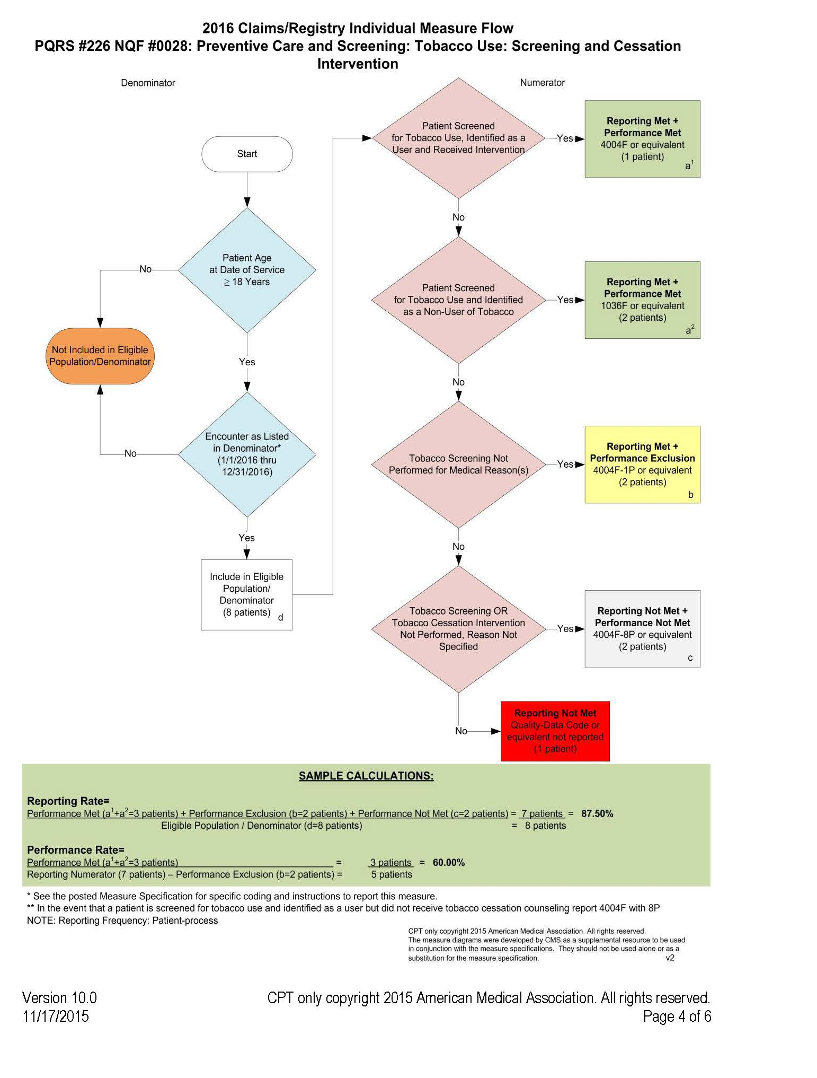

2016 Claims/Registry Individual Measure Flow
PQRS #226 NQF #0028: Preventive Care and Screening: Tobacco Use: Screening and Cessation
Intervention

Please refer to the specific section of the Measure Specification to identify the denominator and numerator information for use in reporting this Individual Measure.

- Start with Denominator
- Check Patient Age:
  - If the Age is greater than or equal to 18 years of age on Date of Service equals No during the measurement period, do not include in Eligible Patient Population. Stop Processing.
  - If the Age is greater than or equal to 18 years of age on Date of Service equals Yes during the measurement period, proceed to check Encounter Performed.
- Check Exclusion Criteria:
  - If patient meets Exclusion Criteria, remove from Denominator
- Check Encounter Performed:
  - If Encounter as Listed in the Denominator equals No, do not include in Eligible Patient Population. Stop Processing.
  - If Encounter as Listed in the Denominator equals Yes, include in the Eligible Population.
- Denominator Population:
  - Denominator population is all Eligible Patients in the denominator. Denominator is represented as Denominator in the Sample Calculation listed at the end of this document. Letter d equals 8 patients in the sample calculation.
- Start Numerator
- Check Patient Screened for Tobacco Use, Identified as a User and Received Intervention:
  - If Patient Screened for Tobacco Use, Identified as a User and Received Intervention equals Yes, include in Reporting Met and Performance Met.
  - Reporting Met and Performance Met letter is represented in the Reporting Rate and Performance Rate in the Sample Calculation listed at the end of this document. Letter a1 equals 1 patient in Sample Calculation.
  - If Patient Screened for Tobacco Use, Identified as User and Received Intervention equals No, proceed to Patient Screened for Tobacco Use and Identified as a Non-User of Tobacco.
- Check Patient Screened for Tobacco Use and Identified as a Non-User of Tobacco:
  - If Patient Screened for Tobacco Use and Identified as a Non-User of Tobacco equals Yes, include in Reporting Met and Performance Met.
  - Reporting Met and Performance Met letter is represented in the Reporting Rate and Performance Rate in the Sample Calculation listed at the end of this document. Letter a2 equals 2 patients in Sample Calculation.
  - If Patient Screened for Tobacco Use and Identified as a Non-User of Tobacco equals No, proceed to Tobacco Screening Not performed for Medical Reason(s).
- Check Tobacco Screening Not Performed for Medical Reason(s):
  - If Tobacco Screening Not Performed for Medical Reason(s) equals Yes, include in Reporting Met and Performance Exclusion.
  - Reporting Met and Performance Exclusion letter is represented in the Reporting Rate and Performance Rate in the Sample Calculation listed at the end of this document. Letter b equals 2 patients in the Sample Calculation.
  - If Tobacco Screening Not Performed for Medical Reason(s) equals No, proceed to Tobacco Screening or Tobacco Cessation Intervention Not Performed, Reason Not Specified.
- Check Tobacco Screening or Tobacco Cessation Intervention Not Performed, Reason Not Specified:
  - If Tobacco Screening or Tobacco Cessation Intervention Not Performed, Reason Not Specified equals Yes, include in the Reporting Met and Performance Not Met.
  - Reporting Met and Performance Not Met letter is represented in the Reporting Rate in the Sample Calculation listed at the end of this document. Letter c equals 2 patients in the Sample Calculation.
  - If Tobacco Screening or Tobacco Cessation Intervention Not Performed, Reason Not Specified equals No, proceed to Reporting Not Met.
- Check Reporting Not Met
  - If Reporting Not Met equals No, Quality Data Code or equivalent not reported. 1 patient has been subtracted from the reporting numerator in the sample calculation.

Post procedure ED visits/admissions

I. BACKGROUND

Measure Title
Post-Procedure ED Visits

Measure Description
Percentage of patients, regardless of age, who underwent an outpatient surgery/procedure and presented to an emergency room within seven days of their surgery/procedure.

Project(s)
1.3 Ambulatory Care Redesign: Specialty Care

Measure Steward Entity(/ies), Organization
SFHN

II. REPORTING

Measure Numerator
Number of PRIME entity emergency department visits resulting from an outpatient specialty procedure/operation completed in the prior 7 days

Numerator Code/s (CPT, ICD10, other)
All attached CPT procedure codes in denominator where the patient presented within 7 days of the procedure/operation to the PRIME entity emergency department (see attached document for CPT/revenue center codes to identify ER visits)

Measure Denominator
Total number of individuals in the eligible population with an outpatient specialty procedure/operation at the PRIME entity facility during the measurement period

Denominator Code/s (CPT, ICD10, other)
See embedded document for CPT procedure codes to include (for outpatient surgeries/procedures)

Exclusion/s
Inpatient procedures/operations; planned admissions post procedure/operation

Reporting Business Logic

Definitions as applicable
Procedures are defined as operative procedures in which skin or mucous membranes and connective tissue are incised or an instrument is introduced through a natural body orifice. This definition is utilized by the Centers for Medicare and Medicaid Services.

Other Notes as applicable

Measurement Period as applicable
DY 11: Final End of Year:
- July 1, 2015 through June 30, 2016
DY 12-DY 15:
- Interim Mid-Year: January 1, 20xx through December 31, 20xx
- Final End of Year: July 1, 20xx through June 30, 20xx

III. RATIONALE

Rationale for Measure
Outpatient procedures (performed by a variety of specialists) have been growing over the last several decades in the U.S. (Jordan 2008). At the same time, many patients may return to the emergency room seeking medical care after their procedure has been completed. A number of reasons may account for this situation including the development of adverse events associated with the procedure, inadequate care coordination and follow-up after the procedure, or poor communication from the team providing medical care to the patient at the time of discharge. These situations have a number of significant implications in terms of providing high-quality and safe healthcare to patients as well as economic consequences for the overall healthcare system.
Utilizing readmission rates as a measure of quality is not new to healthcare and has been used extensively in the inpatient setting over the last several years. In fact, hospital readmission rates have been examined for a number of diseases including pneumonia, myocardial infection and congestive heart failure (Bratzler 2011, Krumholz 2006, Lindenauer 2011) and as a result of this data reporting benchmarks have been set for providers and healthcare facilities in many of these areas. Furthermore, hospital readmission rates have now been incorporated into value based purchasing for hospitals; this now ties payments to hospitals for the quality of care they provide their patients, but also provides transparency of the data so that patients may be able to make informed decisions about where they receive their healthcare.
However, very little data is available with regards to unplanned admissions to emergency rooms for outpatient procedures/surgeries. Additionally, providers performing outpatient procedures may be unaware of patients seeking care for an adverse event related to a procedure (Leffler, 2010). Only recently, has some data been put forth with regards to endoscopic procedures and unplanned emergency room visits. Not surprisingly rates differed significantly across the U.S. suggesting variation in care for patients (Ranasinghe 2016). Yet, such data is lacking for a variety of other specialists who perform outpatient procedures/surgical operations.
Collecting and reporting this data will have a number of benefits for the healthcare system. It will make transparent adverse events that patients may encounter for specialty care procedures, allow patients to make informed decisions where to seek care, create incentives for improved care and help focus performance improvement efforts within specialty care.

Scientific Acceptability
- Ranasinghe I, Parzynski CS, Searfoss R, Montague J et al. Differences in Colonoscopy Quality Among Facilities: Development of a Post-Colonoscopy Risk-Standardized Rate of Unplanned Hospital Visits. Gastroenterology. 2016 Jan;150(1):103-13
- Leffler DA, Kheraj R, Garud S et al. The incidence and cost of unexpected hospital use after scheduled outpatient endoscopy. Arch Intern Med. 2010; 170: 1752-1757
- Bratzler, D.W., Normand, S.L., Wang, Y. et al. An administrative claims model for profiling hospital 30-day mortality rates for pneumonia patients. PLoS One. 2011; 6 (e17401)
- Krumholz, H.M., Wang, Y., Mattera, J.A. et al. An administrative claims model suitable for profiling hospital performance based on 30-day mortality rates among patients with an acute myocardial infarction. Circulation. 2006; 113: 1683–1692
- Lindenauer, P.K., Normand, S.L., Drye, E.E. et al. Development, validation, and results of a measure of 30-day readmission following hospitalization for pneumonia. J Hosp Med. 2011; 6: 142–150
- Jordan MR, Conley J, Ghali WA. Consultation patterns and clinical correlates of consultation in a tertiary care setting. BMC Res Notes 2008;1:96.

Referral Reply Turnaround Rate

I. BACKGROUND

Measure Title
Referral Reply Turnaround Rate

Measure Description
Percentage of requests for specialty care expertise, regardless of patient age, for which the referring provider received a response within 4 calendar days.

Project(s)
1.3 Ambulatory Care Redesign: Specialty Care

Measure Steward Entity(/ies), Organization
LACDHS; San Francisco Health Network

II. REPORTING

Measure Numerator
Number of requests in denominator for whom the request for specialty expertise received a response within 4 calendar days.
- Requests for specialty expertise include both those submitted via eReferral/eConsult and those via traditional mechanisms.
- Individualized response could be the initial reply from the specialist or review and disposition by a Utilization Review Staff person (“approval or denial” for those without eReferral/eConsult). An “auto-response” does not meet the definition of an individualized reply or disposition by a specialist or UR staff person.

Numerator Code/s (CPT, ICD10, other)
Total number of requests for specialty expertise to specialists within the PRIME entity during the measurement period in which a specialist or utilization review staff replied to the referring provider within 4 calendar days.

Measure Denominator
Total number of requests for specialty expertise to specialists within the PRIME Entity during the measurement period.

Specialty site inclusion in the denominator:
- The PRIME Entity must include in their denominator all specialties that use eReferral/eConsult
- AND the PRIME entity must also include in their denominator their top 10 highest volume non-eReferral/eConsult specialties.

Denominator Code/s (CPT, ICD10, other)
Total number of requests for specialty expertise from the PRIME entity during the measurement period, which include the following information: 1) who made the referral, 2) date referral was made, 3) to which specialty the referral was placed and 4) date when response to referral (whether appointment or communication back to referrer) was made.

For tracking of eReferral/eConsult, PRIME entity may choose use either locally developed codes or systems, or may choose to use the CPT codes listed for eReferral/eConsult in the California’s MediCal 2020 Special Terms and Conditions Attachment FF: Global Payment Program Valuation Protocol, Appendix 2: Categories of Service and Point Values, Non-Traditional:
- 99446-99449: Non-Face-To-Face Services: Interprofessional Telephone/Internet Consultations
OR
- 99241-5 with GT modifier

Exclusion/s
None

Reporting Business Logic

Definitions as applicable
Referral: A request from one physician or other eligible provider to another practitioner for evaluation, treatment, or co-management of a patient’s condition.
Eligible Provider: To be determined based on scope of practice and local rules.

Other Notes as applicable

Measurement Period as applicable
DY 11: Final End of Year:
- July 1, 2015 through June 30, 2016
DY 12-DY 15:
- Interim Mid-Year: January 1, 20xx through December 31, 20xx
- Final End of Year: July 1, 20xx through June 30, 20xx

III. RATIONALE

Rationale for Measure

Scientific Acceptability

Specialty Care Touches: Specialty expertise requests managed via non-face to face specialty encounters

I. BACKGROUND

Measure Title
Specialty Care Touches: Specialty Care expertise requests managed via non-face to face specialty encounters

Measure Description
Total number of specialty care requests that were managed via non-face to face encounters.

Project(s)
1.3 Ambulatory Care Redesign: Specialty Care

Measure Steward Entity(/ies), Organization
UCDHS; LACDHS; San Francisco Health Network

II. REPORTING

Measure Numerator
Number of requests for specialty expertise from the denominator that are managed via non-face to face specialty encounters.

Numerator Code/s (CPT, ICD10, other)

Total number of referrals requests to specialists within the system during the specified time frame in which 1) the specialist replied to the referring provider and 2) no patient appointment was scheduled.

Measure Denominator
Total number of requests for specialty expertise to specialists within the PRIME Entity during the measurement period.

Denominator Code/s (CPT, ICD10, other)
Total number of requests for specialty expertise to specialists within the PRIME Entity during the measurement period which includes the following information: 1) who made the referral, 2) date referral was made, 3) to which specialty the referral was placed and 4) date when response to referral (whether appointment or communication back to referrer) was made).

Exclusion/s
Denials from utilization review

Reporting Business Logic

Definitions as applicable
Referral: A request from one physician or other eligible provider to another practitioner for evaluation, treatment, or co-management of a patient’s condition.

Other Notes as applicable

Measurement Period as applicable
DY 11: Final End of Year:
- July 1, 2015 through June 30, 2016
DY 12-DY 15:
- Interim Mid-Year: January 1, 20xx through December 31, 20xx
- Final End of Year: July 1, 20xx through June 30, 20xx

III. RATIONALE

Rationale for Measure

Scientific Acceptability

Closing the Referral Loop (CSM50v4)
eMeasure Title | Closing the Referral Loop: Receipt of Specialist Report
eMeasure Identifier (Measure Authoring Tool) | 50 | eMeasure Version number | 4.0.000
NQF Number | Not Applicable | GUID | f58fc0d6-edf5-416a-8d29-79afbfd24dea
Measurement Period | PRIME 12 month measurement period
Measure Steward | Centers for Medicare & Medicaid Services (CMS)
Measure Developer | National Committee for Quality Assurance
Endorsed By | None
Description | Percentage of patients with referrals, regardless of age, for which the referring provider receives a report from the provider to whom the patient was referred.
Copyright | Limited proprietary coding is contained in the Measure specifications for user convenience. Users of proprietary code sets should obtain all necessary licenses from the owners of the code sets. NCQA disclaims all liability for use or accuracy of any CPT or other codes contained in the specifications.  CPT(R) contained in the Measure specifications is copyright 2004-2014 American Medical Association. LOINC(R) copyright 2004-2014 Regenstrief Institute, Inc. This material contains SNOMED Clinical Terms(R) (SNOMED CT[R]) copyright 2004-2014 International Health Terminology Standards Development Organisation.
Disclaimer | These performance Measures are not clinical guidelines and do not establish a standard of medical care, and have not been tested for all potential applications.  THE MEASURES AND SPECIFICATIONS ARE PROVIDED "AS IS" WITHOUT WARRANTY OF ANY KIND.  Due to technical limitations, registered trademarks are indicated by (R) or [R] and unregistered trademarks are indicated by (TM) or [TM].
Measure Scoring | Proportion
Measure Type | Process
Stratification | None
Risk Adjustment | None
Rate Aggregation | None
Rationale | Problems in the outpatient referral and consultation process have been documented, including lack of timeliness of information and inadequate provision of information between the specialist and the requesting physician (Gandhi, 2000; Forrest, 2000; Stille, 2005). In a study of physician satisfaction with the outpatient referral process, Gandhi et al. (2000) found that 68% of specialists reported receiving no information from the primary care provider prior to referral visits, and 25% of primary care providers had still not received any information from specialists 4 weeks after referral visits. In another study of 963 referrals (Forrest, 2000), pediatricians scheduled appointments with specialists for only 39% and sent patient information to the specialists in only 51% of the time.  In a 2006 report to Congress, MedPAC found that care coordination programs improved quality of care for patients, reduced hospitalizations, and improved adherence to evidence-based care guidelines, especially among patients with diabetes and CHD. Associations with cost-savings were less clear; this was attributed to how well the intervention group was chosen and defined, as well as the intervention put in place. Additionally, cost-savings were usually calculated in the short-term, while some argue that the greatest cost-savings accrue over time (MedPAC, 2006).  Improved mechanisms for information exchange could facilitate communication between providers, whether for time-limited referrals or consultations, on-going co-management, or during care transitions. For example, a study by Branger et al. (1999) found that an electronic communication network that linked the computer-based patient records of physicians who had shared care of patients with diabetes significantly increased frequency of communications between physicians and availability of important clinical data. There was a 3-fold increase in the likelihood that the specialist provided written communication of results if the primary care physician scheduled appointments and sent patient information to the specialist (Forrest, 2000).  Care coordination is a focal point in the current health care reform and our nation's ambulatory health information technology (HIT) framework. The National Priorities Partnership recently highlighted care coordination as one of the most critical areas for development of quality measurement and improvement (NPP, 2008).
Clinical Recommendation Statement | None
Improvement Notation | A higher score indicates better quality
Reference | Branger, P. J., Van't Hooft, A., Van Der Wouden, J. C., Moorman, P. W., and Van Bemmel, J. H. (1999). Shared care for diabetes: supporting communication between primary and secondary care. International Journal of Medical Informatics 53(2-3), 133-142.
Reference | Forrest, C. B., Glade, G. B., Baker, A. E., Bocian, A., Von Schrader, S., and Starfield, B. (2000). Coordination of specialty referrals and physician satisfaction with referral care. Archives of Pediatrics and Adolescent Medicine 154(5), 499-506.
Reference | Gandhi, T. K., Sittig, D. F., Franklin, M., Sussman, A. J., Fairchild, D. G., and Bates, D. W. (2000). Communication breakdown in the outpatient referral process. Journal of General Internal Medicine 15(9), 626-631.
Reference | Medicare Payment Advisory Commission (MedPAC) Report to the Congress: Medicare Payment Policy.March, 2006. Retrieved September 22, 2009 from http://www.medpac.gov/documents/Mar06_EntireReport.pdf.
Reference | National Priorities Partnership. National Priorities and Goals: Aligning Our Efforts to Transform America's Healthcare. Washington, DC: National Quality Forum; 2008.
Reference | Stille, C. J., Jerant, A., Bell, D., Meltzer, D., and Elmore, J. G. (2005). Coordinating care across diseases, settings, and clinicians: a key role for the generalist in practice. Annals of Internal Medicine 142(8), 700-708.
Definition | Referral: A request from one physician or other eligible provider to another practitioner for evaluation, treatment, or co-management of a patient's condition. This term encompasses referral and consultation as defined by Centers for Medicare and Medicaid Services.
Guidance | The provider to whom the patient was referred should be the same provider that sends the report.  If there are multiple referrals for a patient during the measurement period, use the first referral.
Transmission Format | TBD
Initial Population | Number of patients, regardless of age, who were referred by one provider to another provider, and who had a visit during the measurement period.
Denominator | Equals Initial Population
Denominator Exclusions | None
Numerator | Number of patients with a referral, for which the referring provider received a report from the provider to whom the patient was referred.
Numerator Exclusions | Not Applicable
Denominator Exceptions | None
Measure Population | Not Applicable
Measure Population Exclusions | Not Applicable
Measure Observations | Not Applicable
Supplemental Data Elements | For every patient evaluated by this measure also identify payer, race, ethnicity and sex.

Table of Contents
- Population Criteria
- Data Criteria (QDM Variables)
- Data Criteria (QDM Data Elements)
- Supplemental Data Elements
- Risk Adjustment Variables

Population Criteria
- Initial Population =
  - AND: First: "Occurrence A of Intervention, Performed: Referral" during "Measurement Period"
  - AND: Union of:
    - "Encounter, Performed: Preventive Care- Initial Office Visit, 0 to 17"
    - "Encounter, Performed: Preventive Care - Established Office Visit, 0 to 17"
    - "Encounter, Performed: Preventive Care Services - Established Office Visit, 18 and Up"
    - "Encounter, Performed: Preventive Care Services-Initial Office Visit, 18 and Up"
    - "Encounter, Performed: Office Visit"
    - "Encounter, Performed: Face-to-Face Interaction"
    - "Encounter, Performed: Ophthalmological Services"
    - during "Measurement Period"
- Denominator =
  - AND: Initial Population
- Denominator Exclusions =
  - None
- Numerator =
  - AND: "Communication: From Provider to Provider: Consultant Report" satisfies all
    - fulfills "Occurrence A of Intervention, Performed: Referral"
    - during "Measurement Period"
- Numerator Exclusions =
  - None
- Denominator Exceptions =
  - None
- Stratification =
  - None

Data Criteria (QDM Variables)
- None

Data Criteria (QDM Data Elements)
- "Communication: From Provider to Provider: Consultant Report" using "Consultant Report Grouping Value Set (2.16.840.1.113883.3.464.1003.121.12.1006)"
- "Encounter, Performed: Face-to-Face Interaction" using "Face-to-Face Interaction Grouping Value Set (2.16.840.1.113883.3.464.1003.101.12.1048)"
- "Encounter, Performed: Office Visit" using "Office Visit Grouping Value Set (2.16.840.1.113883.3.464.1003.101.12.1001)"
- "Encounter, Performed: Ophthalmological Services" using "Ophthalmological Services Grouping Value Set (2.16.840.1.113883.3.526.3.1285)"
- "Encounter, Performed: Preventive Care - Established Office Visit, 0 to 17" using "Preventive Care - Established Office Visit, 0 to 17 Grouping Value Set (2.16.840.1.113883.3.464.1003.101.12.1024)"
- "Encounter, Performed: Preventive Care Services - Established Office Visit, 18 and Up" using "Preventive Care Services - Established Office Visit, 18 and Up Grouping Value Set (2.16.840.1.113883.3.464.1003.101.12.1025)"
- "Encounter, Performed: Preventive Care Services-Initial Office Visit, 18 and Up" using "Preventive Care Services-Initial Office Visit, 18 and Up Grouping Value Set (2.16.840.1.113883.3.464.1003.101.12.1023)"
- "Encounter, Performed: Preventive Care- Initial Office Visit, 0 to 17" using "Preventive Care- Initial Office Visit, 0 to 17 Grouping Value Set (2.16.840.1.113883.3.464.1003.101.12.1022)"
- "Intervention, Performed: Referral" using "Referral Grouping Value Set (2.16.840.1.113883.3.464.1003.101.12.1046)"

Supplemental Data Elements
- "Patient Characteristic Ethnicity: Ethnicity" using "Ethnicity CDCREC Value Set (2.16.840.1.114222.4.11.837)"
- "Patient Characteristic Payer: Payer" using "Payer SOP Value Set (2.16.840.1.114222.4.11.3591)"
- "Patient Characteristic Race: Race" using "Race CDCREC Value Set (2.16.840.1.114222.4.11.836)"
- "Patient Characteristic Sex: ONC Administrative Sex" using "ONC Administrative Sex AdministrativeGender Value Set (2.16.840.1.113762.1.4.1)"

Risk Adjustment Variables
- None

DHCS All-Cause Readmissions (ICD- 9)
All-Cause Readmissions (ACR)

Medi-Cal Managed Care – Statewide Collaborative Quality Improvement Project

FINAL Specifications Revised 11/26/13 - Modified from HEDIS®10 Specifications

Note: Plans should follow the most current HEDIS specifications each year and apply the collaborative defined modifications as outlined in this document.

Description

For the individuals in the Project 1.3 Target Population who are 21 years of age and older, the number of acute inpatient stays during the measurement year that were followed by an acute readmission for any diagnosis within 30 days. Data are reported in the following categories:

1. Count of Index Hospital Stays (IHS) (denominator)

2. Count of 30-Day Readmissions (numerator)

Gray shading indicates deviation from the HEDIS specification.

Definitions
Definitions
HIS | Index hospital stay. An acute inpatient stay with a discharge on or between January 1 and December 1 of the measurement year. Exclude stays that meet the exclusion criteria in the denominator section.
Index Admission Date | The IHS admission date.
Index Discharge Date | The IHS discharge date. The index discharge date must occur on or between January 1 and December 1 of the measurement year.
Index Readmission Stay | An acute inpatient stay for any diagnosis with an admission date within 30 days of a previous Index Discharge Date.
Index Readmission Date | The admission date associated with the Index Readmission Stay.

Eligible Population
Product line | Medi-Cal
Ages | 21 years and older as of the Index Discharge Date
Continuous enrollment | 120 days prior to the Index Discharge Date through 30 days after the Index Discharge Date.
Allowable gap | None.
Anchor date | Index Discharge Date.
Benefit | Medical.
Event/ diagnosis | An acute inpatient discharge on or between January 1 and December 1 of the measurement year. The denominator for this measure is based on discharges, not members. Include all acute inpatient discharges for members who had one or more discharges on or between January 1 and December 1 of the measurement year. The organization should follow the steps below to identify acute inpatient stays

Administrative Specification

Denominator The Project 1.3 target population

Step 1 Identify all acute inpatient stays with a discharge date on or between January 1 and
December 1 of the measurement year for the PRIME midyear measurement period or between July 1 and June 1 of the measurement period for the PRIME year end measurement period

Include acute admissions to behavioral healthcare facilities. Exclude nonacute inpatient rehabilitation services, including nonacute inpatient stays at rehabilitation facilities.

Step 2 Acute-to–acute transfers: Keep the original admission date as the Index Admission
Date, but use the transfer’s discharge date as the Index Discharge Date.

Step 3 Exclude hospital stays where the Index Admission Date is the same as the Index
Discharge Date.

Step 4 Exclude any acute inpatient stay with a discharge date in the 30 days prior to the
Index Admission Date.

Step 5 Exclude stays for the following reasons.

• Inpatient stays with discharges for death

• Acute inpatient discharge with a principal diagnosis for pregnancy or for any other condition originating in the perinatal period in Table 1.

Step 6 Calculate continuous enrollment.

Table 1: Codes to Identify Maternity Related Inpatient Discharges

ICD-9-CM
Description Diagnosis
Pregnancy | 630-679, V22, V23, V28
Conditions originating in the perinatal period | 760-779, V21, V29-V39

Numerator: At least one acute readmission for any diagnosis within 30 days of the index discharge date

Step 1 Identify all acute inpatient stays with an admission date on or between January 1 and December 31 or between July 1 and June 1 of the measurement period for the PRIME year end measurement period

Step 2 Acute-to-transfers: Keep the original admission date as the Index Admission Date, but use the transfer’s discharge date as the index discharge date

Step 3 Exclude acute inpatient hospital discharges with a principal diagnosis using the codes listed in Table 1.

Step 4 For each IHS, determine if any of the acute inpatient stays have an admission date within 30 days after the Index Discharge Date

Reporting: Denominator

Count the number of IHS for the total eligible population.

Reporting: Numerator

Count the number of IHS with a readmission within 30 days for the total population.

Quality Improvement Project Reporting Requirements |  | or members enrolled in the plan for each
Plans are required to report on three distinct populations f county:
1. Overall readmission rate
2. Seniors and Persons with Disabilities (SPD) readmission rate*
3. Non-SPD readmission rate
* Seniors and Persons with Disabilities are defined in Table 2.

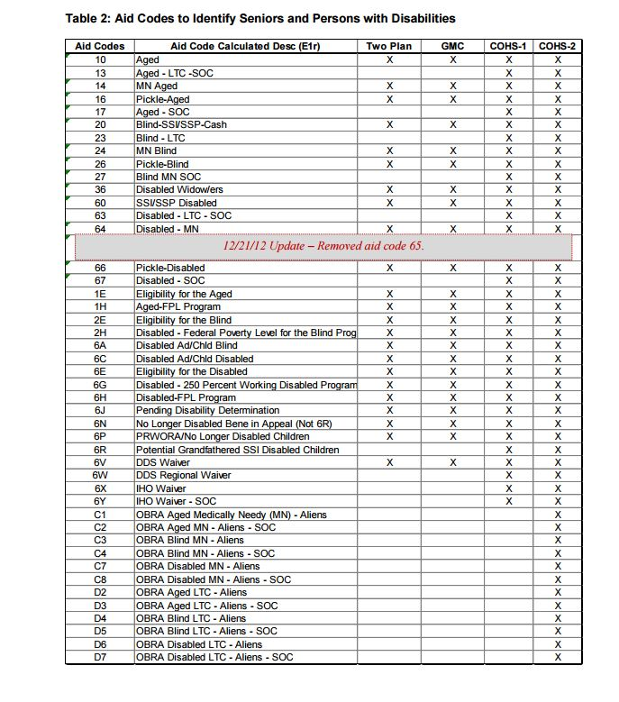

Non-traditional service encounters as listed in California’s MediCal 2020 Special Terms and Conditions Attachment FF: Global Payment Program Valuation Protocol, Appendix 2: Categories of Service and Point Values, Non-Traditional
A CMS value set is the complete set of codes used to identify a service or condition included in a measure. The value set references are underlined in the specifications (e.g. BMI Percentile Value Set). The Value Set Directory is available at: http://www.medicaid.gov/Medicaid-CHIP-Program-Information/By-Topics/Quality-of-Care/Downloads/2015-Adult-Value-Set-Directory.zip, Accessed on 2/26/2016. For a Value Set Directory User Manual, refer to Appendix A in the 2015 Core Set of Adult Health Care Quality Measures for Medicaid.
RTR - eConsult CPT Codes, UC Davis. https://static1.squarespace.com/static/52d9c6c5e4b021f2d93416db/t/534c2d9fe4b0d8fffdf288f5/1397501343957/CPT+Codes.pdf, Accessed 10/2/2015 plus communication 10/27/2015 with Time Leslie, Blue Path Health and Rachel Wick, Blue Shield of CA Foundation in reference to BSCF eConsult grant program.

